
Western Australian Certificate of Education
Semester 2 Examination, 2022

EXAM SOLUTIONS

Please place your student identification label in this box (if required)
BIOLOGY

Year 12 ATAR: Units 3 & 4

Student Number: | In figures
 | In words

Time allowed for this paper
Reading time before commencing work: ten minutes
Working time: three hours

Materials required/recommended for this paper
To be provided by the supervisor
This Question/Answer booklet
Multiple-choice answer sheet

To be provided by the candidate
Standard items: pens (black and blue preferred), pencils (including coloured), sharpener, correction fluid/tape, eraser, ruler, highlighters
Special items: non-programmable calculators approved for use in this examination

Important note to candidates
No other items may be taken into the examination room. It is your responsibility to ensure that you do not have any unauthorised material. If you have any unauthorised material with you, hand it to the supervisor before reading any further.

Structure of this Paper
Section | Number of questions available | Number of questions to be answered | Suggested working time (minutes) | Marks available | Percentage of examination
Section One  Multiple Choice | 30 | 30 | 40 | 30 | 30
Section Two  Short answer | 5 | 5 | 90 | 100 | 50
Section Three  Extended answer | 4 | 2 | 50 | 40 | 20
 |  |  |  | Total | 100

Instructions to candidates

- The rules for the conduct of the Western Australian external examinations are detailed in the Year 12 Information Handbook 2022: Part II. Sitting this examination implies that you agree to abide by these rules.
- Write your answers in this Question/Answer booklet preferably using a blue/black pen. Do not use erasable or gel pens.
- Answer the questions according to the following instructions. Section One should be answered on the Multiple-Choice answer sheet. Sections Two and Three: Write your answers in this Question/Answer booklet. Wherever possible, confine your answer to the line spaces provided.
Section Three: Consists of four questions. You must answer two of the four questions.
- You must be careful to confine your answers to the specific questions asked and to follow any instructions that are specific to a particular question.
- Supplementary pages for planning/continuing your answers to questions are provided at the end of this Question/Answer booklet. If you use these pages to continue an answer, indicate at the original answer where the answer is continued, i.e. give the page number.

Section One: Multiple-choice 30% (30 marks)
This section has thirty questions. Answer all questions on the separate Multiple-choice answer sheet provided. For each question shade the box to indicate your answer. Use only a blue or black pen to shade the boxes. Do not use erasable or gel pens. If you make a mistake, place a cross through that square, then shade your new answer. Do not erase or use correction fluid/tape. Marks will not be deducted for incorrect answers. No marks will be given if more than one answer is completed for any question.
Suggested working time: 40 minutes.

Question 1 | a
Question 2 | b
Question 3 | d
Question 4 | a
Question 5 | d
Question 6 | d
Question 7 | d
Question 8 | b
Question 9 | a
Question 10 | c
Question 11 | b
Question 12 | b
Question 13 | b
Question 14 | c
Question 15 | d

Question 16 | c
Question 17 | d
Question 18 | c
Question 19 | c
Question 20 | d
Question 21 | a
Question 22 | c
Question 23 | b
Question 24 | c
Question 25 | b
Question 26 | a
Question 27 | b
Question 28 | d
Question 29 | c
Question 30 | b

END OF SECTION ONE

Section Two: Short answer 50% (100 Marks)
This section has 5 questions. Answer all questions. Write your answers in the spaces provided.
Supplementary pages for planning/continuing your answers to questions are provided at the end of this Question/Answer booklet. If you use these pages to continue an answer, indicate at the original answer where the answer is continued, i.e., give the page number.
Suggested working time: 90 minutes.

- (20 marks)
A group of biology students was carrying out an experiment on the rate of transpiration in three different plants. The apparatus they used (a potometer) is shown below. As the plant transpires, the air bubble moves along the tubing, and the volume of water lost to the air can be measured.

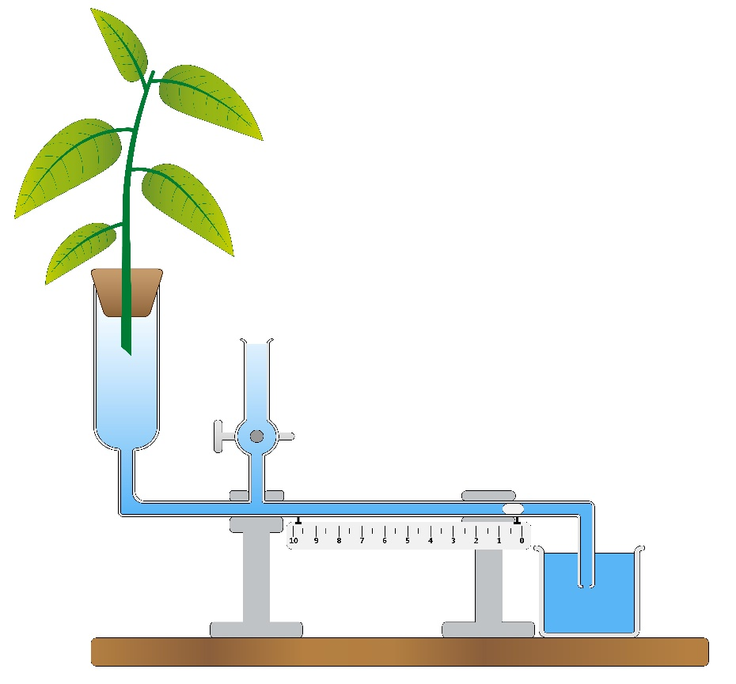
Air bubble
Leafy shoot

The three species of plant used in the experiment were a eucalypt from the desert, a rose bush from the school garden, and spinifex grass from a sand dune. The pieces of plant cut for the experiment all had the same mass, and were kept at the same temperature throughout the experiment. There were 5 groups of students, and each group had 2 samples of leaves from each type of plant. The results from the experiment are shown on the next page.

Plant type | Volume of water transpired (mL) in 15 minutes
 | eucalypt | rose | spinifex
Group 1 | 3.8 | 4.9 | 1.1
 | 3.6 | 5.1 | 1.0
Group 2 | 3.7 | 5.0 | 1.2
 | 3.6 | 4.8 | 1.0
Group 3 | 3.3 | 4.9 | 1.3
 | 3.2 | 4.7 | 0.9
Group 4 | 3.5 | 4.3 | 0.9
 | 3.6 | 4.2 | 1.1
Group 5 | 3.7 | 4.4 | 1.2
 | 3.8 | 4.2 | 0.8
Mean

- Calculate the missing mean values for each column and write your answers in the space in the table. (3 marks)
Description | Mark
3.58 in column 1 or rounded to 3.6 | 1
4.65 in column 2 or rounded to 4.6 | 1
1.05 in column 3 or rounded to 1.0 | 1
Total | 3

- Write a possible hypothesis for this experiment (2 marks)
Description – Teacher discretion, but must name both independent and dependent variables in hypothesis. Some suggestions below | Mark
Transpiration rate depends on the origin of the plant OR | 2
Plants with narrow leaves lose less water than plants with broad leaves | 2
Total | 2

- Name three (3) controlled variables in this experiment. (3 marks)
Description | Mark
same mass of plant | 1
same temperature | 1
same apparatus | 1
Total | 3

- Name the dependent and the independent variables in this experiment.
(2 marks)
Description | Mark
Dependent: volume of water lost | 1
Independent: type of plant | 1
Total | 2

- Graph the mean values on the grid below (5 marks)
There is a spare grid on page 50. If you need to redraw your graph on the spare grid, clearly show that graph below is cancelled.
Description | Mark
title | 1
labels including units on both axes | 1
Correct scales on both axes | 1
column graph | 1
accurate plotting of values | 1
Total | 5

- The plant that lost the least water was the spinifex. Name 2 structural adaptations that this plant may have to help it to reduce water loss. (2 marks)
Description: any 2 of the following | Mark
sunken stomata | 1
rolled leaves | 1
hairy leaves | 1
reduced leaf area | 1
Total | 2

- If the students set up a fan and blew air over the leafy shoot, what would you predict would happen to the volume of water lost? Explain your answer briefly.
(3 marks)
Description | Mark
volume of water lost would increase | 1
because air movement would remove water vapour from the leaf surface | 1
and increase the concentration gradient between the air and the internal leaf spaces | 1
Total | 3
- (20 marks)
Thermoregulation is the control of the body’s temperature. It is common in endothermic animals, which can alter their metabolic rate to create more heat when the environmental temperature falls. Metabolic control of temperature also occurs in some plant species, such as members of the aroid family. The photograph below shows a skunk cabbage (Symplocarpus foetidis) growing in snow, which has melted around the plant as it produces heat.
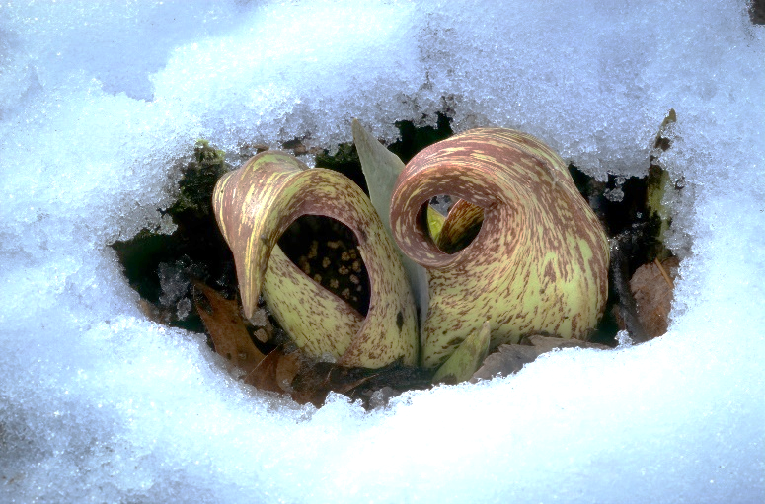
Spathe

Spadix

The heat-producing organ is called the spadix, a spike of tiny flowers closely arranged around a fleshy axis. It is contained within the spathe, which wraps around the flower. Heat is produced by a form of cellular respiration, and is initiated by plant hormones. These plants are pollinated by beetles, which are attracted by scent produced within the spathe.
- List three (3) advantages that producing heat gives to this plant. (3 marks)
Description | Mark
warmer internal temperature allows enzymes to work faster/increases metabolism | 1
scent that attracts pollinating beetles will be more readily dispersed/volatilised | 1
pollinators will be attracted to a warmer place to escape the cold | 1
Total | 3

- Other than the metabolic method described above, describe two (2) structural and one (1) physiological adaptation that enable plants to cope with high temperatures.
(6 marks)
Description | Mark
Structural: (any 2)
- vertically hanging leaves – less absorption of sunlight and heat | 2
- silvery coating on leaf – reflects sunlight | 2
- hairy leaves – reduce transpiration rate and reflect sunlight | 2
Physiological: (any 1)
- increased transpiration rate – cools the leaves due to evaporation of water | 2
- different pigments in leaf (red) to protect the leaf from damage by strong sunlight | 2
Total | 6

- Some mammals, including humans and horses, use sweat as a means of heat loss. Explain why sweating reduces the heat load of an organism. (2 marks)
Description | Mark
Evaporation of water requires the input of heat energy to bring about the change of state from liquid to gas | 1
The heat is provided by the animal’s body and is therefore removed when the sweat evaporates | 1
Total | 2

- Briefly explain the effect of body size on the heat budget (i.e., how much heat is gained/lost) of organisms. (5 marks)
Description | Mark
Large animals have a low surface area to volume ratio (or small animals have a high surface area to volume ratio) | 1
Large animals retain heat more easily (or small animals lose heat more readily) | 1
Large endothermic animals in hot climates (eg elephants) have other structures to assist with heat loss (eg highly vascularised and mobile ears) | 1
Large ectothermic animals (eg crocodiles) can gain heat via their body surface and regulate heat gain and loss by changing their body position | 1
Small endothermic animals have a higher metabolic rate to compensate for greater heat loss/use behavioural methods to stay warm or cool off | 1
Total | 5

- Ectothermic animals such as reptiles have a range of behavioural adaptations to aid in temperature regulation. Name two (2) examples of behavioural adaptations used by reptiles and state how they help to control the body temperature of the animal.
(4 marks)
Description: any 2 of these | Mark
Body orientation – lie in the sun with long side of body exposed to the sunlight to increase body temperature. | 1
More area = more absorption and body temperature increases | 1
Use contact with warm surfaces such as rocks to gain heat | 1
Body contact conducts heat from rock to animal’s body | 1
Avoids contact with hot surfaces when temperature rises, either by moving to shade/burrow or by removing body parts from contact (eg lifts tail and lifts alternate legs from the rock) | 1
Body temperature drops when heat source is removed | 1
Total | 4

- (20 marks)
- Many pathogenic bacteria have evolved a resistance to the antibiotics that have been used in the past to treat infections. These resistant forms cause significant problems for people or animals that become infected with them. Describe how such resistance develops in bacterial groups. (5 marks)
Description: Must have first 3 points then any two of the next three | Mark
all populations contain genetic variation | 1
when the infection is treated with an antibiotic, not all individuals will be susceptible due to natural variation | 1
Individuals not susceptible will survive and reproduce due to reduced competition | 1
New population contains more individuals that are resistant | 1
With further treatment, all susceptible individuals will die and the survivors are all resistant to the antibiotic | 1
May also mention that resistance can be passed to other bacteria by horizontal gene transfer | 1
Total | 5

- Explain the process of allopatric speciation. (5 marks)
Description | Mark
occurs when a population is divided by a geographic barrier, eg river, lava flow, mountain range, expanding desert | 1
gene flow between the two populations is reduced to zero | 1
different selection pressures act on the two populations | 1
genetic drift occurs differently/acts on random alleles within each population | 1
Accumulated micro-evolutionary changes lead to new species that can no longer interbreed and produce fertile offspring | 1
Total | 5

- The organisms below are all marine and represent 3 different Classes of vertebrates. Despite not having a common ancestor for approximately 450 million years, these organisms have very similar body shapes and diets. What factors have led to these animals looking so similar? (A is a shark, B is an extinct ichthyosaur, C is a dolphin and D is a killer whale). (5 marks)

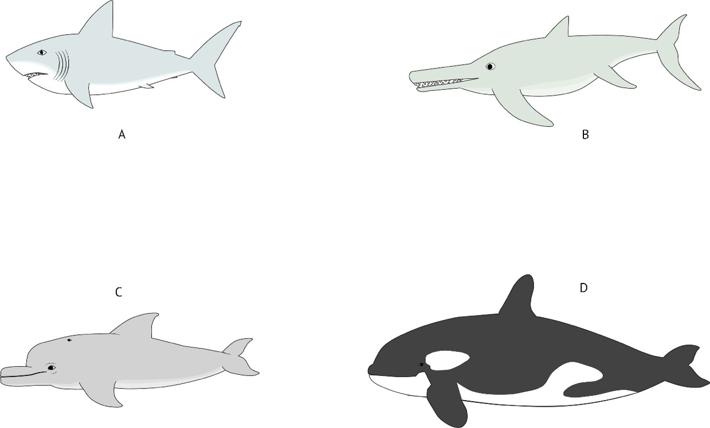

Description | Mark
Aquatic habitat selects for particular characteristics | 1
such as streamlined body shape, fins for stability, muscular tails for propulsion | 1
all these organisms are predators so speed through the water is an advantage | 1
ancestral forms of each type were acted on by selection pressures | 1
giving rise to organisms with similar body shapes | 1
Total | 5

- What is the difference between natural selection and sexual selection, and how does the latter impact on the allele frequencies in a population? (3 marks)
Description | Mark
Sexual selection is a form of natural selection which is linked to mating behaviour | 1
Males or females select mates based on characteristics or behaviours and individuals that have these are more likely to obtain mates and pass on their genes | 1
Sexual selection will favour some alleles over others and so alter the gene pool | 1
Total | 3

- What is meant by the term “genetic drift”? (2 marks)
Description | Mark
Genetic drift is the change in allele frequency caused by random chance | 1
Has a greater impact in small populations because the loss of an allele from a small gene pool cannot be replaced | 1
Total | 2

- (20 marks)
- Explain briefly how each of the following factors impacts on the spread of a contagious disease that infects humans. (4 marks)
- Socio-economic status:
Description | Mark
Low socio-economic status increases the spread due to overcrowding, lack of medical facilities, poor sanitation | 1
Total | 1

- Global travel:
Description | Mark
Global travel increases the spread of contagious diseases rapidly within and between countries | 1
Total | 1

- Population density:
Description | Mark
The denser the population, the more readily a disease can spread because of close contact between affected and unaffected individuals | 1
Total | 1

- Mode of transmission:
Description | Mark
Air-borne or water borne pathogens spread rapidly, as do pathogens that survive on fomites and so infect new individuals indirectly | 1
Total | 5

- Explain how each of the following is used to control the spread of diseases. (8 marks)
- Immunisation:
Description | Mark
Immunisation increases the number of individuals who cannot pass on the infection and so reduces the spread | 1
Herd immunity protects individuals who cannot be vaccinated | 1
Total | 2

- Quarantine:
Description | Mark
Quarantine separates infected individuals from the rest of the population | 1
thus reducing the rate of spread of a contagious disease | 1
Total | 2

- Medications:
Description | Mark
Antibiotics kill or reduce the bacterial infections so that the immune system can overcome it | 1
Antivirals combat viruses and reduce the severity of the disease.  In both cases, the spread is reduced because there are fewer infected people | 1
Total | 2

- Physical prevention:
Description: any 2 of these | Mark
hand washing and gloves prevent the spread by minimising the contamination of surfaces | 1
mask wearing reduces spread by filtering pathogens from the air and from the breath of infected individuals | 1
condoms provide a barrier to sexually transmitted diseases | 1
Total | 2

- Describe the structure and mode of transmission of the following pathogenic organisms: (8 marks)
- Crown gall of plants:
Description | Mark
Bacterium: (Agrobacterium tumefaciens) prokaryotic cells, no membrane bound organelles, cell wall of glycoprotein, produces spores into the soil | 1
spreads from soil into damaged plant and multiplies, then transfers a plasmid into the plant cells that results in uncontrolled cell growth | 1
Total | 2

- Chytridiomycosis:
Description | Mark
Fungus: (Batrachochytrium dendrobatidis) thallus of hyphae and sporangia growing on the skin of amphibians. Sporangia produce motile spores asexually | 1
Direct and indirect transmission (skin to skin and waterborne spores) | 1
Total | 2

- Phytophthora dieback:
Description | Mark
Protist: (Phytophthora cinnamoni) grows via cellulose-based mycelium and reproduces via chlamydospores and zoospores | 1
Spreads through damp soil and infects the roots of susceptible plants. Can be direct transmission (root to root contact) or indirect (on vehicles and footwear) | 1
Total | 2

- Malaria:
Description | Mark
Protist: (Plasmodium spp.) unicellular eukaryotic cells that reproduce sexually and asexually, producing sporozoites and merozoites at different times in its life cycle | 1
Spreads via mosquito vectors which inject the organism into a human host | 1
Total | 2

- (20 marks)
- Define the term “osmoregulation” and name the process by which water moves in and out of cells. (3 marks)
Description | Mark
Osmosis | 1
Osmoregulation is the maintenance of water balance within | 1
organisms and cells via homeostatic mechanisms | 1
Total | 3

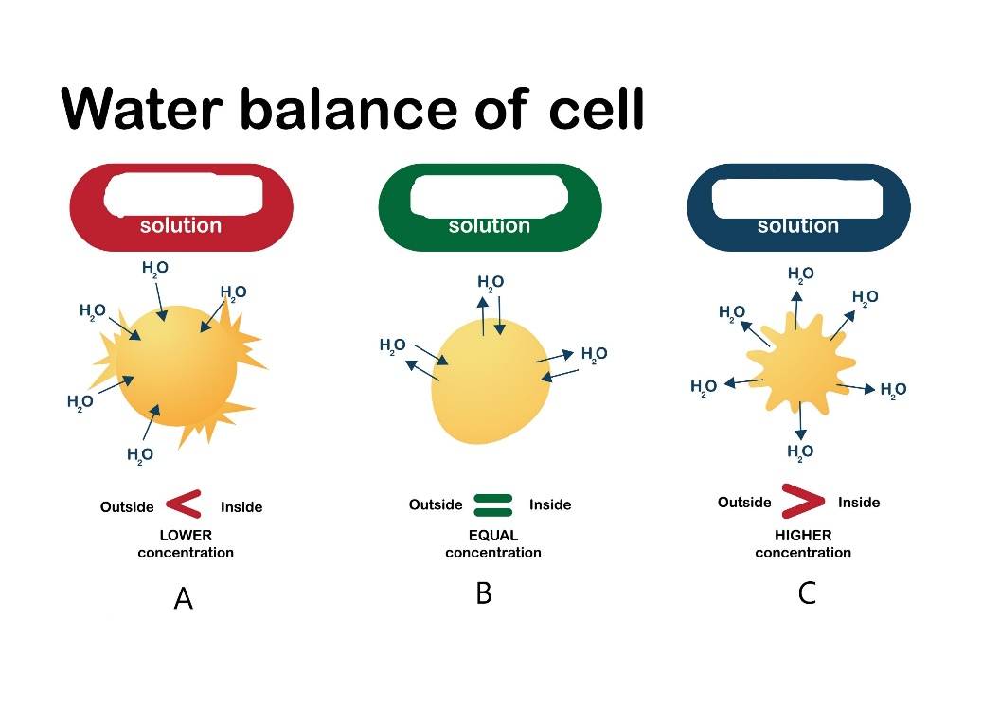
- The diagram below shows the movement of water into and out of a cell. The solutions around the cells are either less concentrated, more concentrated or the same concentration as the inside of the cell, but the labels have been erased. Write the correct scientific term for each of the solutions shown by the letters A – C. (3 marks)

Description | Mark
A: hypotonic | 1
B: isotonic | 1
C: hypertonic | 1
Total | 3

- The fish below is a carp, which lives in a fresh water habitat. Briefly describe how each of the labelled parts contributes to the maintenance of water balance in this fish.
(4 marks)

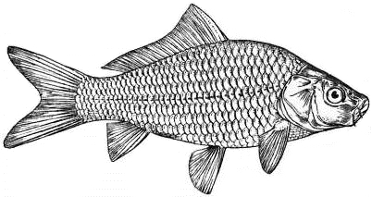
Gills
Kidneys
Scales
Mouth

Scales
Kidneys
Gills
Mouth

Description | Mark
Scales: physically block the movement of water from the water into the fish | 1
Kidneys: many glomeruli, retain salts and excrete copious volumes of dilute urine | 1
Gills: actively absorb salts from the water | 1
Mouth: minimises drinking to reduce the amount of water ingested | 1
Total | 4

- Using a named example of an Australian animal, briefly describe how a species that lives in the desert can survive with minimal availability of water. (5 marks)
Description: teacher discretion: answers will vary. | Mark
Possible examples (any 1 of the following): desert hopping mice, water holding frog, reptiles | 1
Subtotal | 1
Possible water saving mechanisms: (any 4 of the following – to a max of 4 marks)
- burrowing to escape the worst of the heat, | 1
- metabolic water (derived from food), | 1
- producing highly concentrated urine | 1
- producing urea | 1
- seasonal activity (eg water holding frog stays underground until rail falls) | 1
Subtotal | 4
Total | 5

- Using a named example of an Australian plant, describe the adaptations that allow it to grow successfully in a saline environment. (5 marks)
Description: teacher discretion: answers will vary | Mark
Possible examples: saltbush, mangroves, | 1
Subtotal | 1
Possible adaptations
roots impervious to salts | 1
storage of excess salts in vacuoles | 1
storage of excess salts in specialised bladders or leaves that can be dropped off the plant to reduce the salt load | 1
salt glands on leaves | 1
Subtotal | 4
Total | 5

END OF SECTION TWO

Section Three: Extended Answer 20% (40 Marks)
This section contains 4 questions. Questions 36 and 37 are from Unit 3. Questions 38 and 39 are from Unit 4. Answer 1 question from Unit 3 and 1 question from Unit 4.
Use a blue or black pen, and a pencil for diagrams and graphs. Responses can include: labelled diagrams with explanatory notes; lists of points with linking sentences; labelled tables and/or graphs; annotated flow diagrams with introductory notes.
Supplementary pages for planning/continuing your answers to a question are provided at the end of this Question/Answer booklet. If you use these pages to continue an answer, indicate at the original answer where the answer is continued, i.e. give the page number.
Suggested working time: 50 minutes.

Choose either Question 36 or Question 37.

Indicate which question you are answering by ticking the box. Write your answer to question 36 or 37 on the pages following Question 37, and your answer to Question 38 or 39 from page 30.

Question 36 (20 marks)
- Discuss four different patterns of inheritance and how they influence the relative proportions of offspring to produce different phenotypes and genotypes. (10 marks)
Description (students may also answer using Punnett squares) | Mark
Autosomal dominant | 1
- Homozygotes crossed with any other combination produced phenotypes with the dominant trait expressed and at least one dominant allele in the genotype | 1
- 2 heterozygotes crossed produce a 3:1 ratio of dominant: recessive phenotypes | 1
Sex linked recessive | 1
- Affected mothers pass the trait on to 50% of her sons, affected fathers result in 100% carrier daughters (normal phenotypes) | 1
Co-dominance | 1
- Both traits are expressed in heterozygotes, homozygotes for each trait when crossed produce only one phenotype and genotype (eg human blood types A, O, B, AB) | 1
Incomplete dominance | 1
- Produces a blending of the trait (eg red flower x white flower pink flower) | 1
- 2 heterozygotes crossed will produce a ratio of 1:2:1,  - 2 homozygotes (one of each trait) crossed produce 100% blended offspring that are heterozygous genotypes | 1
Total | 10

- Describe how the genetic code holds the information needed to allow the organism to function, and how that information is used to produce proteins. (10 marks)
Description: must have bold words for full marks | Mark
Genetic code is held in the order of bases on the DNA molecules | 1
Each set of 3 bases makes up a codon that determines the order of amino acids | 1
A gene consists of a length of DNA that codes for a particular protein | 1
A gene is read when enzymes unzip the double helix and expose the bases | 1
Genes are copied during transcription when an mRNA molecule is made on the exposed bases | 1
The mRNA is modified by adding a poly-A tail and by the removal of introns | 1
The mRNA moves to the cytoplasm and attaches to a ribosome for translation to occur | 1
The ribosome moves along the mRNA and tRNA molecules bring specific amino acids to the ribosome | 1
where they are joined into a polypeptide chain | 1
The polypeptide chain is released from the ribosome and undergoes folding into its final structure to make a functional protein | 1
Total | 10

Question 37 (20 marks)
- Mutation refers to a permanent, heritable change in the DNA of an organism. Describe how mutations can arise, and discuss the impact that they have on the organism.
(10 marks)

Description: max 5 marks for the first part of the question and 5 marks for the second part | Mark
First part: | max 5
Mutations can arise randomly during DNA replication or cell division | 1
or may be induced by exposure to physical, chemical or biological mutagens | 1
Physical mutagens include ionising radiation, X-rays and UV light | 1
Chemical mutagens include mustard gas, colchicine, | 1
Biological mutagens include some bacteria that invade host tissue and cause uncontrolled cell division | 1
May affect reproductive cells (germline) or other body cells (somatic) | 1
Mutation may involve a single base (point mutation) or whole sections of chromosomes (deletion or insertion mutations) | 1
Second part: | max 5
Mutations may be neutral – having no effect on the individual, usually because the substituted base does not alter the protein being coded for | 1
Mutations may be deleterious/harmful because they alter the structure of one or more proteins and render them unfit for their purpose | 1
Most mutations are deleterious | 1
Mutations can be beneficial if they produce a new allele that increases the survival of the individual | 1
Variations in the ploidy level/number of chromosomes are often fatal, or produce offspring with serious physical and/or mental and/or developmental issues | 1
Somatic mutations may lead to cancer as they may cause an increase in the rate of cell division or switch off apoptosis | 1
Total | 10

- Phylogenetic trees can be used to represent evolutionary relationships. Outline the steps involved in creating these trees, and discuss the reasons that they are subject to change over time. (10 marks)

Description | Mark
Different organisms are compared with respect to particular features | 1
The features may be anatomical, physiological or genetic. | 1
The presence or absence of a particular feature is noted | 1
Organisms with the most features in common are considered to be the most closely related | 1
The organisms are then lined up either horizontally or vertically, and a branching tree is drawn to show the relationships among the different organisms. | 1
Each branch shows where a particular feature causes the organisms to move away from each other | 1
These trees are subject to change over time because scientific knowledge grows | 1
Trees drawn from purely anatomical differences may be modified as either biochemical or genetic differences become evident | 1
Different scientists may also put a different emphasis on the same traits and so come up with different trees | 1
Trees that are partially based on fossils may change as more fossils are discovered that give a clearer view of body shape | 1
Total | 10

Choose either Question 38 or Question 39.

Indicate which question you are answering by ticking the box.

Question 38 (20 marks)
- Explain how feedback mechanisms operate within organisms to maintain homeostasis.
(10 marks)
Description: A well drawn and labelled flow chart that shows these points could also be used to answer this question | Mark
Homeostasis refers to the processes that maintain the internal environment of an organism within tolerance limits | 1
Feedback mechanisms are those that detect changes in the state of different factors and work to return the body to a stable state | 1
Feedback systems can be negative or positive, with negative being much more common | 1
In a feedback system, a stimulus is defined as any change in the normal stable status of the body | 1
Receptors within the body detect the change in state. Receptors can detect changes in the chemical state of the body (eg oxygen levels), osmotic conditions, light, and temperature | 1
A modulator (or coordinating centre) receives a message from the receptor, coordinates a response and sends a message to the effector | 1
The effector (usually a muscle or a gland) receives the message from the control centre and carries out a response | 1
The response is the action that works to counter the effect of the stimulus | 1
In negative feedback systems, the response reduces the stimulus | 1
In positive feedback systems, the response enhances the stimulus | 1
Total | 10

- Using named examples, discuss the impact of climate change on the spread of diseases. (10 marks)
Description: must name examples as in bold below. Other examples may also be valid | Mark
All organisms, including pathogens, have a set of optimum living conditions where their needs are met | 1
Climate change can alter the environment in different ways eg. More/less rainfall, or higher/lower temperatures in an area. | 1
Diseases such as malaria and Ross River Virus which are spread by mosquito vectors, and need a supply of standing water for reproduction | 1
are likely to change their distribution in response to climate change. | 1
If more rain falls, there will be more standing water for the mosquitos to breed in (and the reverse is also true) so the rate of disease spread would increase (or decrease with less rain fall) | 1
If the rain fall increase is spread over a larger geographic area, then the distribution of the disease will also spread because | 1
the mosquitos will carry the disease with them as they spread out into new areas | 1
Longer periods of drought will weaken host species’ immunity and cause a greater spread of disease | 1
Phyophthora dieback spreads through wet or damp soil, so a decrease in rain fall may reduce its spread | 1
but it may also increase the severity of the disease because it puts plants under water stress | 1
Total | 10

Question 39 (20 marks)
- Discuss the energy costs involved in the production of different types of nitrogenous wastes, and the advantages and disadvantages of each type in different environments.
(10 marks)
Description | Mark
Three types of nitrogenous wastes are ammonia, urea and uric acid | 1
Ammonia is the simplest molecule and is a direct breakdown product of proteins. It is highly soluble and highly toxic to cells and must be rapidly removed | 1
Urea is more complex, and requires modification of ammonia and therefore energy expenditure. It is slightly toxic and moderately soluble | 1
Uric acid is the most complex and requires more input of energy to create it. It is insoluble and can be stored in the body without harming the organism | 1
Ammonia is excreted by aquatic animals with an abundance of water to help flush it from their bodies | 1
Urea is excreted by mammals and its higher energy cost are compensated for by removing the need for rapid removal. Wastes can be stored in the bladder without harm. | 1
Urea requires water to excrete it so the animal needs an available source of water, making it suitable for land based animals with a water supply. | 1
Uric acid is excreted by birds and reptiles. It can be stored in their bodies and eggs without harm because it is insoluble. | 1
Uric acid takes more energy to make but the trade off is it takes little water to excrete and so is suitable for desert dwelling organisms | 1
Because uric acid is stored as a paste, not a solution, there is less weight to carry, which has an energy advantage for birds in flight | 1
Total | 10

- Viral diseases include influenza, Ross River virus and the bat lyssavirus. Describe the structure of viruses in general, then chose one of these and discuss the mode of transmission, impact on the affected individual and what treatments are available.
(10 marks)
Description: general discussion of virus structure |  |  | Mark
Viruses consist of a protein coat (=capsid) and a nucleic acid core. |  |  | 1
the nucleic acid can be DNA or RNA but not both |  |  | 1
Viruses are smaller than other pathogens (up to 300 nm in length) |  |  | 1
Influenza | Ross River virus | Bat lyssavirus
single strand RNA virus | Single strand RNA virus | single strand RNA virus | 1
transmitted by direct contact or indirectly airborne particles or fomites. Is contagious | Indirect transmission by mosquitos. Is not contagious (ie you can’t catch it from an infected person) | transmitted by direct contact with bats or their saliva or urine. Is not contagious | 1
Infected individuals suffer aches, fever, coughs, over-active nasal secretions | Infected individuals develop a rash and joint pain which may persist for many months | Infected individuals have their nervous system attacked leading to paralysis, delirium, convulsions and sometimes death | 1
Some strains may be fatal, especially in elderly people | The effects can be long term | the effects can be fatal | 1
Viruses do not respond to antibiotic treatment |  |  | 1
Prevention is more effective than treatments, so reducing contact with infected people (influenza), mosquitos (RRV)and bats (lyssavirus) will help reduce the spread. |  |  | 1
Treatment is aimed at minimising symptoms. For some diseases (eg AIDS), anti-viral medication is available |  |  | 1
Total |  |  | 10

ACKNOWLEDGEMENTS

Question 15: | The Blood Type Distribution Around the World downloaded under private account  Image: https://www.statista.com/chart/25386/blood-type-distribution-selected-countries/  Author: Claire Jenik 22/07/2021
Questions 27: | “Gene cloning. Plasmid and recombinant DNA” by Honourr used under permission form Shutterstock  Image: https://www.shutterstock.com/image-vector/gene-cloning-plasmids-recombinant-dna-2148808119  Author: www.shutterstock.com/Honourr
Question 31: | “Potometer with leafy shoot, ruler and stand” by Biology Education used under permission from Shutterstock  Image: https://www.shutterstock.com/image-illustration/potometer-leafy-shoot-ruler-stand-1958120458  Author: www.shutterstock.com/ Biology education
Question 32 (a): | “Skunk cabbage blooming after a snow storm” by Gerry Bishop used under permission from Shutterstock  Image: https:// https://www.shutterstock.com/image-photo/flowers-skunk-cabbage-symplocarpus-foetidus-blooming-1352232041  Author: www.shutterstock.com/Gerry Bishop
Question 33 (c) | “Convergent evolution of shark, ichthyosaur, dolphin and killer whale” by Sergey Mukilov used under permission from Shutterstock  Image: https:// https://www.shutterstock.com/image-vector/convergent-evolution-shark-ichthyosaurus-dolphin-killer-1574905360  Author: www.shutterstock.com/Sergey Mukilov
Question 35 (a): | “Water balance of cell” by Big Bear Camera used under permission from Shutterstock  Image: https://www.shutterstock.com/image-vector/biology-diagram-show-effect-isotonic-hypertonic-1756773080  Author: www.shutterstock.com/Big Bear Camera
Question 35 (c): | “The common Carp”  File EB1911  Used under permission from Creative Commons CC0 license

